Phase 1 – Database Design:
In the Entire database design we can classify our warehouse into 3 Dimension tables and 2 facts
Dimension Tables Creation
- Employee Dimension (SCD Type 2)
Source code for creation:
CREATE TABLE DIM_EMPLOYEE (
EMP_SK NUMBER GENERATED BY DEFAULT AS IDENTITY PRIMARY KEY,
EMP_ID NUMBER NOT NULL,
EMP_NAME VARCHAR2(100),
GENDER VARCHAR2(10),
AGE NUMBER,
DEPT_ID NUMBER,
DESIGNATION VARCHAR2(100),

HIRE_DATE DATE,

EFFECTIVE_START_DATE DATE,
EFFECTIVE_END_DATE DATE,

CURRENT_FLAG CHAR(1),

CONSTRAINT CHK_CURRENT
CHECK (CURRENT_FLAG IN ('Y','N'))
);

Output:
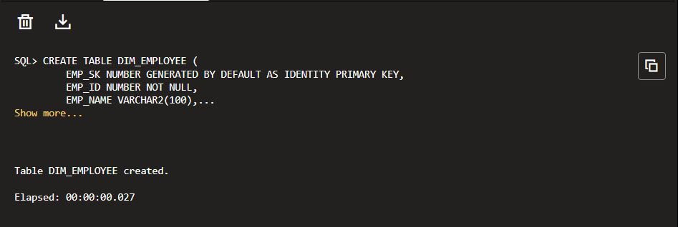

- Department Dimension
Source code for creation:
CREATE TABLE DIM_DEPARTMENT (

DEPT_ID NUMBER PRIMARY KEY,

DEPARTMENT_NAME VARCHAR2(100),

COST_CENTER VARCHAR2(50),

LOCATION VARCHAR2(100),

BUSINESS_UNIT VARCHAR2(100)

);

Output:
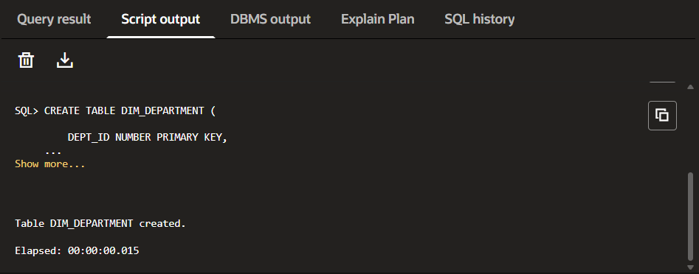

- Calendar Dimension
Source code for creation:
CREATE TABLE DIM_CALENDAR (

DAY_ID NUMBER PRIMARY KEY,

FULL_DATE DATE,

MONTH NUMBER,

QUARTER NUMBER,

YEAR NUMBER
);
Output:
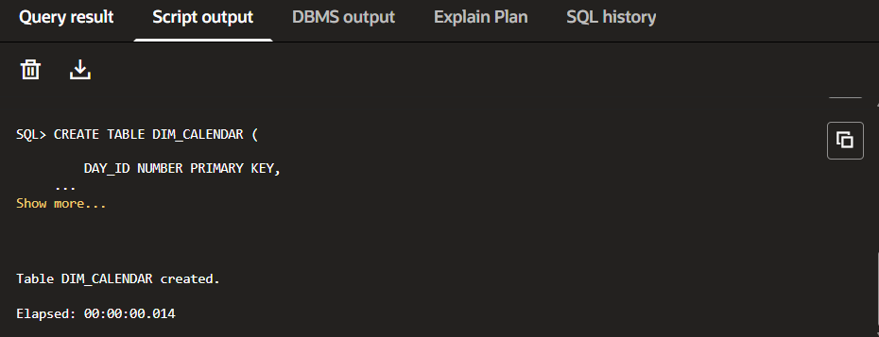

Fact Table Creation
- Performance Review Fact
Source code for Creation:
CREATE TABLE FACT_PERFORMANCE (

PERFORMANCE_ID NUMBER GENERATED BY DEFAULT AS IDENTITY PRIMARY KEY,

EMP_SK NUMBER,

REVIEW_DATE DATE,

RATING_SCORE NUMBER(2,1),

KPI_PERCENTAGE NUMBER(5,2),

MANAGER_SK NUMBER,

PROMOTION_FLAG CHAR(1),

FOREIGN KEY (EMP_SK)
REFERENCES DIM_EMPLOYEE(EMP_SK),

FOREIGN KEY (MANAGER_SK)
REFERENCES DIM_EMPLOYEE(EMP_SK)

);

Output:
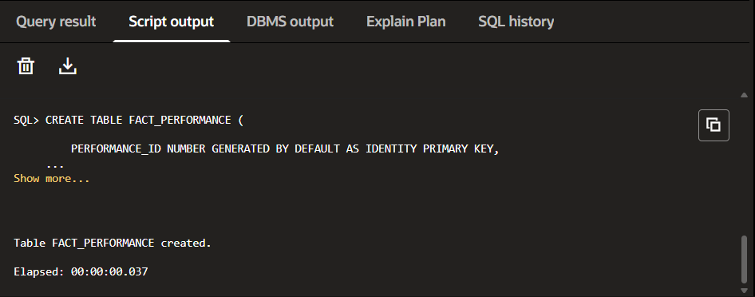

- Attrition Fact
Source code for Creation:
CREATE TABLE FACT_ATTRITION (

ATTRITION_ID NUMBER GENERATED BY DEFAULT AS IDENTITY PRIMARY KEY,

EMP_SK NUMBER,

EXIT_DATE DATE,

EXIT_REASON VARCHAR2(30),

NOTICE_PERIOD NUMBER,

REPLACEMENT_COST NUMBER(12,2),

REGRETTABLE_ATTRITION CHAR(1),

FOREIGN KEY (EMP_SK)
REFERENCES DIM_EMPLOYEE(EMP_SK)

);

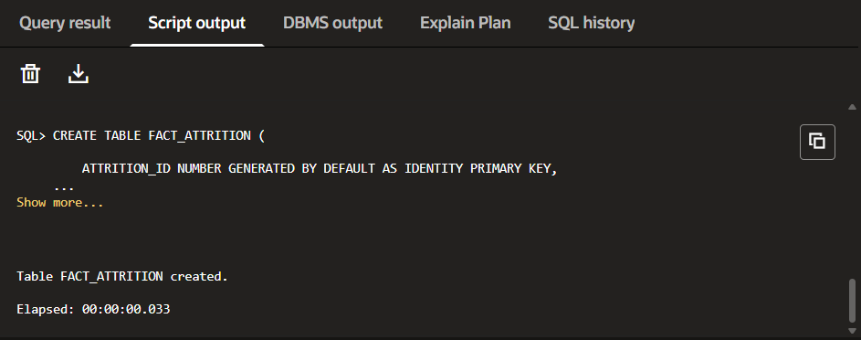
Output:

